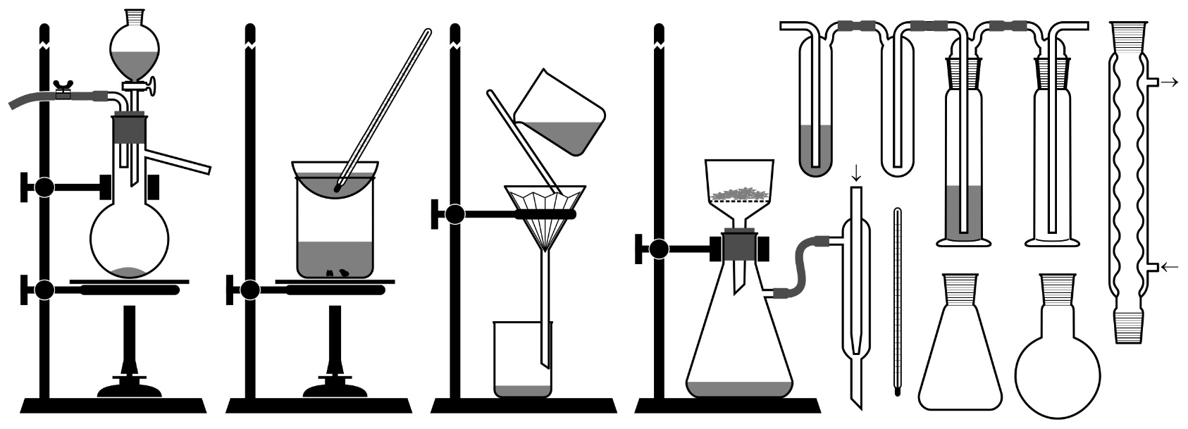
https://anorganika.online/semester/labaky_aparatura.pdf
https://anorganika.online/semester/labaky_aparatura.pdf
https://anorganika.online/semester/labaky_aparatura.pdf

